Raul Aguilar

Professor Paulding

CS 220 2148

October 9, 2020

Homework 5 Machine Language

Div.asm

// Initialize R0 = 16

@16 // RAM[16] selected

D = A // D = 16

@R0 // RAM[0] selected

M = D // RAM[0] = 16

// Initialize R1 = 3

@3 // RAM[3] selected

D = A // D = 3

@R1 // RAM[1] selected

M = D // RAM[1] = 3

// Divide 16 by 3

(LOOP)

@R1 // RAM[1] selected

D = M // D = 3; store the divisor in D register

@R0 // RAM[0] selected

MD = M - D // Subtract divisor from dividend(16 - 3), store answer in D reg and memory location

@ENDLOOP

D;JLE // If dividend <= 0, quotient found so jump to end of loop

// otherwise, continue

@R2 // RAM[2] selected; where the answer is stored

M = M + 1 // Increment quotient by 1

@LOOP

0;JMP // Jump back to start of loop

(ENDLOOP) // Label to jump to the end of the loop

@ENDLOOP

0;JMP // Infinite loop to end program

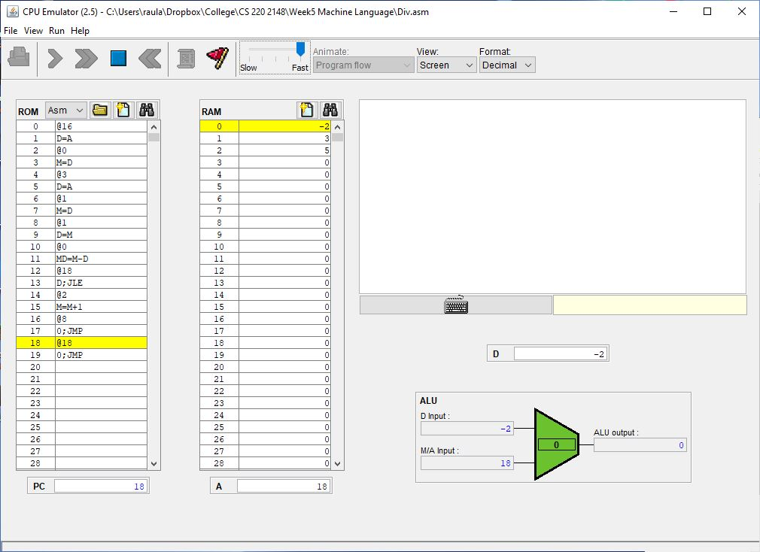

CS220.asm